

Year 7 Science 2018 Name: ___________________
Biology 2 Test
Test TOTAL: _____ / 25 marks

SECTION 1: MULTIPLE CHOICE (1 mark each)
Circle your answer in the multiple choice section on page 3.

- Which of these is not a biotic factor in an ecosystem?
  - sunshine
  - predators
  - competition
  - commensalism

- In an ecosystem, producers are those things that
  - make their own food.
  - are eaten by consumers.
  - eat decaying material.
  - eat other organisms.

- Animals that kill and eat other animals are called
  - consumers.
  - predators.
  - omnivores.
  - scavengers.

- Which of these is another name for a first order (primary)consumer?
  - plant
  - herbivore
  - carnivore
  - omnivore

- The origin of all energy in an ecosystem is
  - plants.
  - the sun.
  - heat.
  - animals.

- Which of the following is least likely to upset the natural balance of an ecosystem?
  - Killing off or removing all of one species of plant or animal.
  - Introducing a new pest insect.
  - Climate change caused by carbon emissions and global warming.
  - Seasonal variation in temperature or rainfall.

- Desert hopping mice dig burrows and sleep in them during the day to escape the heat. When it gets cold they snuggle together to keep warm, but when it gets hot, they spread themselves out. This is an example of
  - a physiological adaptation.
  - a functional adaptation.
  - a structural adaptation.
  - a behavioural adaptation.

The next three questions refer to the following diagram

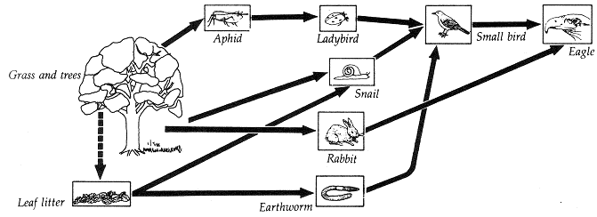

- The producer(s) in this ecosystem are
  - grass and trees.
  - leaf litter.
  - aphids, rabbits and snails.
  - eagle

- The ladybird is
  - a primary consumer.
  - a secondary consumer.
  - a tertiary consumer.
  - an omnivore.

- Which organism is a decomposer?
  - leaf litter
  - earthworm
  - eagle
  - small bird

Multiple Choice Answer Section

Circle your answer:

- A B C D 6. A B C D

- A B C D 7. A B C D

- A B C D 8. A B C D

- A B C D 9. A B C D

- A B C D 10. A B C D

TOTAL MARK FOR M/C: _____ /10 MARKS

SECTION 2: WRITTEN
Write your answers in the spaces provided.

- Observe the diagram below of an aquarium.
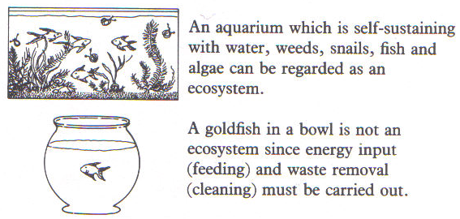

List two biotic and two abiotic factors in the aquarium ecosystem. (4 marks)

Biotic Factors

_________________________________

_________________________________

Abiotic factors

_________________________________

_________________________________

- The diagram below describes some of the species that live in a Eucalyptus woodland ecosystem. Use the information to answer the questions below.
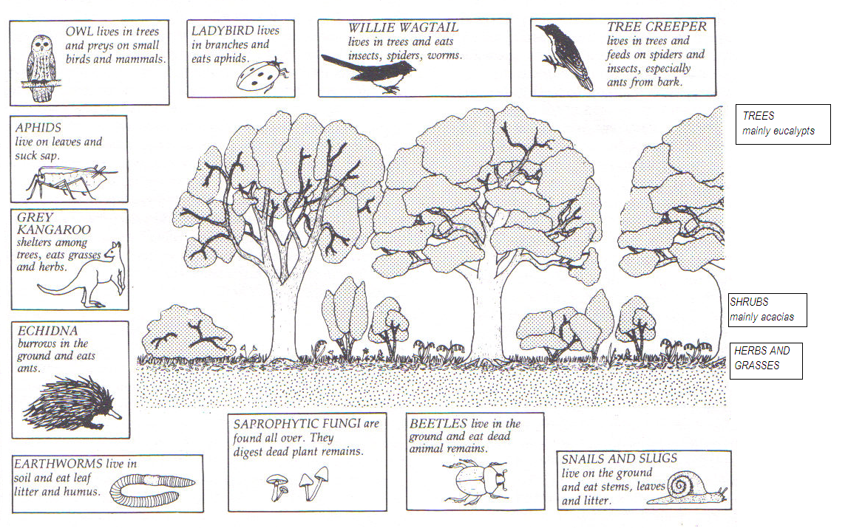
For the Eucalyptus woodland ecosystem shown above:
- Name one producer. (1 mark)

____________________________________

- Name two first order (primary) consumers. (2 marks)

____________________________________________________________

- Name two decomposers. (2 marks)

____________________________________________________________

- Draw a food chain containing at least four organisms (1 mark)

- Which animal is the highest order consumer? (1 mark)

- What is the relationship between the aphid and the ladybird? (1 mark)

____________________________________________________________

- Describe one effect of the removal of the Eucalypt trees by logging.
(1 mark)

____________________________________________________________

- Briefly describe one adaptation of Eucalypt trees that allows them to live in their environment. (2 marks)

____________________________________________________________

____________________________________________________________

END OF TEST (OUT OF 25 MARKS)

